Lab 03 – Worksheet

Name: Aqsa Muneer, Maleeha Nasir Khan | ID: am10527, mk09991 | Section: T1

Note: Assumptions and logics should be explained separately in tasks after the task results.

Task 1

Provide appropriately commented codes (Mention question part before each part)
# addi a0 x0 1
# addi a1 x0 42
# ecall

addi x10,x0,12
addi x11,x0,12
jal x1, sum #calls the function named sum
addi x11, x10, 0
li x10,1
ecall
j exit

sum:
add x10,x11,x10
jalr x0,0(x1)

exit:

Add screenshot of your results (register)
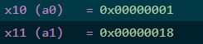

Task 2

Provide appropriately commented codes (Mention question part before each part)
.text
.globl main
main:

li x10, 8 #g
li x11, 7 #h
li x12, 6 #i
li x13, 5 #j

li x20, 0 #f

addi sp, sp, -12
sw x20, 8(sp)
sw x19, 4(sp)
sw x18, 0(sp)

jal x1, sum

lw x18, 0(sp)
lw x19, 4(sp)
lw x20, 8(sp)

addi sp, sp, 12

addi x11, x10, 0
li x10, 1
ecall

end:
j end

sum:
add x18, x10, x11
add x19, x12, x13
sub x10, x18, x19

jalr x0, 0(x1)

Add screenshot of your results
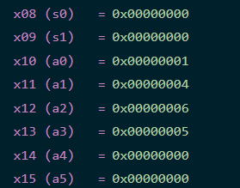

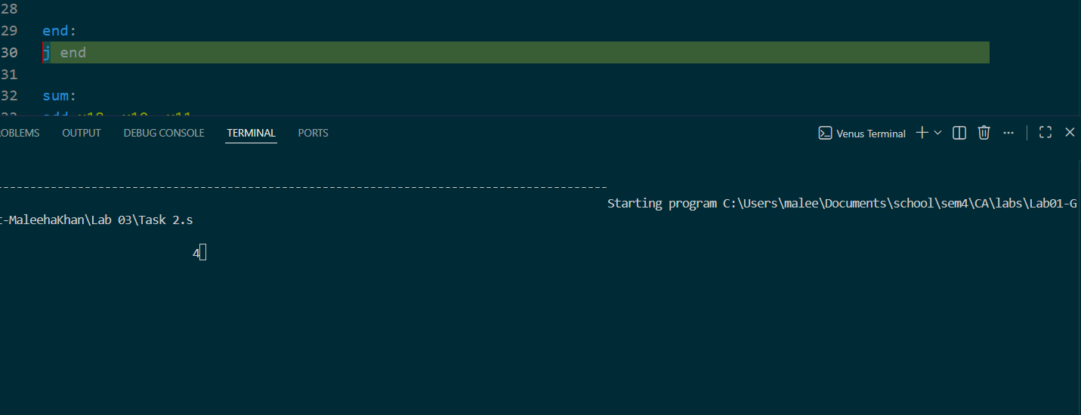

Task 3 Provide appropriately commented codes (Mention question part before each part)
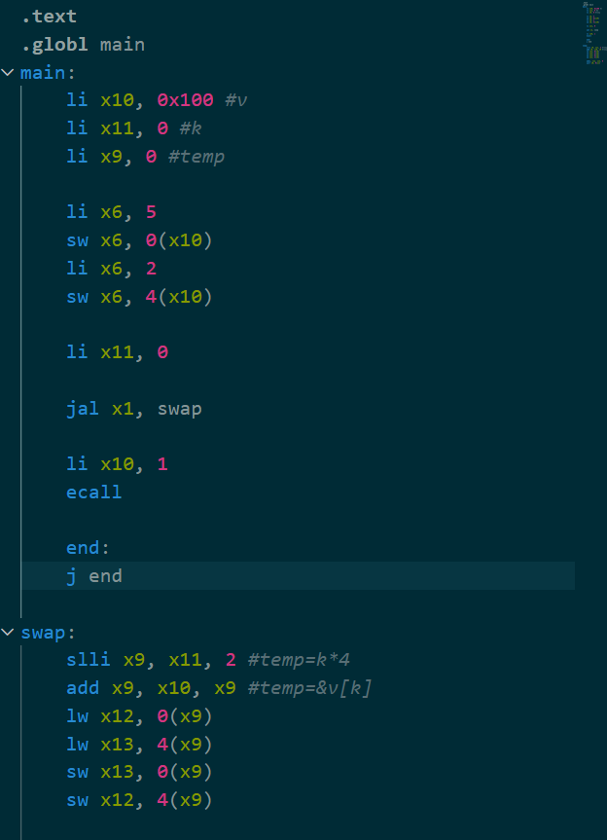
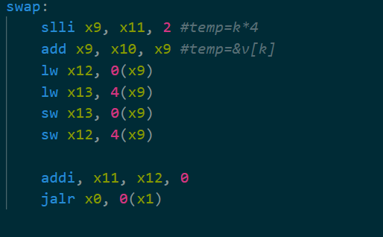

Add screenshots of your results
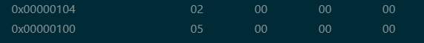
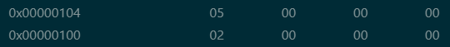
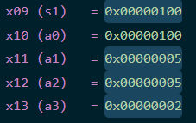

Task 4 Provide appropriately commented codes

.text
.globl main
.text
.globl main
main:
li x10, 0x100
li x11, 0x200
li x19, 0
li x6, 'A'
sb x6, 0(x11)
li x6, 'M'
sb x6, 4(x11)
li x6, 'M'
sb x6, 8(x11)
li x6, 'K'
sb x6, 12(x11)
addi sp, sp, -12
sw x11, 8(sp)
sw x10, 4(sp)
sw x19, 0(sp)

loop1:
lb x17, 0(x11)
sb x17, 0(x10)
beq x17, x0, exit
addi x10, x10, 4
addi x11, x11, 4
addi x19, x19, 1
j loop

exit:
lw x11, 8(sp)
lw x10, 4(sp)
lw x19, 0(sp)
addi sp, sp, 12

Add screenshots of your results
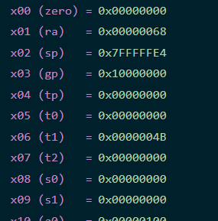
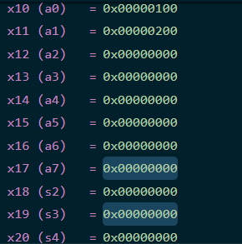
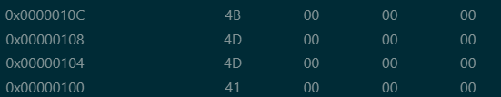

Lab 03 – Introduction to RISC V Assembly (Jumps and Returns)

Assessment Rubrics

Points Distribution
Task No. | LR2  Code | LR5  Results | AR7  Report  Submission and Git Upload
Task 1 | /10 | /05 | /10 & /10
Task 2 | /10 | /10
Task 3 | /10 | /10
Task 4 | /15 | /10
Total Points | /100 Points
CLO Mapped | CLO 2
For description of different levels of the mapped rubrics, please refer the provided Lab Evaluation Assessment Rubrics and Affective Domain Assessment Rubrics.
# | Assessment Elements | Level 1: Unsatisfactory  Points 0-1 | Level 2: Developing  Points 2 | Level 3:Good  Points 3 | Level 4:Exemplary  Points 4
LR2 | Program/Code/ Simulation Model/ Network Model | Program/code/simulation model/network model does not implement the required functionality and has several errors. The student is not able to utilize even the basic tools of the software. | Program/code/simulation model/network model has some errors and does not produce completely accurate results. Student has limited command on the basic tools of the software. | Program/code/simulation model/network model gives correct output but not efficiently implemented or implemented by computationally complex routine. | Program/code/simulation /network model is efficiently implemented and gives correct output. Student has full command on the basic tools of the software.
LR5 | Results & Plots | Figures/ graphs / tables are not developed or are poorly constructed with erroneous results. Titles, captions, units are not mentioned. Data is presented in an obscure manner. | Figures, graphs and tables are drawn but contain errors. Titles, captions, units are not accurate. Data presentation is not too clear. | All figures, graphs, tables are correctly drawn but contain minor errors or some of the details are missing. | Figures / graphs / tables are correctly drawn and appropriate titles/captions and proper units are mentioned. Data presentation is systematic.
AR9 | Report | All the in-lab tasks are not included in report and / or the report is submitted too late. | Most of the tasks are included in report but are not well explained. All the necessary figures / plots are not included. Report is submitted after due date. | Good summary of most the in-lab tasks is included in report. The work is supported by figures and plots with explanations. The report is submitted timely. | Detailed summary of the in-lab tasks is provided. All tasks are included and explained well. Data is presented clearly including all the necessary figures, plots and tables.

